DATA BULLY
- Exploratory analyses
- Do children differ in terms of being a bully based on the child’s tendency to fight?

Linear regression:

LOESS:

SPLINE:

A sample of 32 groups was randomly selected from the data. Based on the graphs of linear regression, cubic regression, and spline, we can tell that generally, there’s a positive relationship between bully and tendency to fight. Group differences can also be observed from the graphs.

By using joint points, linear regression, and cubic regression, we obtained the three graphs above. Based on these graphs, a positive relationship between bully and tendency to fight can be observed.

By plotting the relationship between bully and fight for each peer group in the same plot using joined points, linear regression, and cubic regression, we can observe a positive relationship between bully and tendency to fight. Also, different groups have different slopes.

- Do children differ in terms of being a bully based on the child’s empathy for others?

Linear regression:

LOESS:

Spline:

According to the graphs of linear regression, cubic regression, and spline of predicting bully by empathy, generally there’s a negative relationship between bully and empathy for others. Group differences in overall levels can be observed, too.

Based on the graphs of relationships between bully and empathy using joined points, linear regression, and cubic regression, generally, there’s a negative relationship between bully and empathy for others.

According to the plots of the relationship between bull and empathy for each group in the same graph using joined points, linear regression, and cubic regression, there’s a negative relationship between bully and empathy. In addition, differences in slopes among groups can be observed.

- How does gender predict bully?

According to the plots of bully by fight and empathy for each gender, we can observe that there is probably an interaction effect between fight and gender, being that males high in fight tend to be more likely to be bullies than females with same level of fight.
It can also be observed that there’s an interaction effect between gender and empathy, being that when empathy levels are low, males tend to be more likely to be bullies than females, but when empathy levels are high, males tend to be less likely to be bullies than females.
Results summary:
According to the exploratory analyses, bully and tendency to fight are positively related, while bully and empathy are negatively related. A random intercept, a random slope for empathy, and a random slope for tendency to fight are all possible. There’s a probable interaction effect between gender and tendency to fight, and there’s an interaction effect between gender and empathy.

- Model fitting and refinement

Model 1: null model with random intercept and no explanatory variable

(Bully)_{ij} = β_{0j} + R_{ij}
Β_{0j} = γ₀₀ + U_{0j}
R_{ij} ~ N (0, σ²) U_{0j} ~ N (0, τ₀²)

As shown in the tables above, the intra-class correlation is 0.2046/ (0.2046 + 0.2051) = 0.40, which indicates that the individuals in the same group have high correlations with each other, and therefore, the null model is not appropriated for the data.

Model 2: the full model with mean fight and empathy, mean-centered fight and empathy, and interaction terms between gender and fight and empathy.

(Bully)_{ij} = β_{0j} + β_{1j} (grpCfight)_{ij} + β_{2j} (grpCempathy)_{ij} + β_{3j} (gender)_{ij} + R_{ij}
β_{0j} = γ₀₀ + γ₀₁ (grpMfight)_{j} + γ₀₂ (grpMempathy)_{j} + U_{0j}
β_{1j} = γ₁₀ + γ₁₁ (gender)_{ij} + γ₁₂ (grpMfight)_{j} + U_{1j}
β_{2j} = γ₂₀ + γ₂₁ (gender)_{ij}
β_{3j} = γ₃₀
R_{ij} ~ N (0, σ²) U_{0j} ~ N (0, τ₀²) U_{1j} ~ N (0, τ₁²)

Model 3: model 2 with the interaction between gender and mean-centered empathy, and gender and mean-centered fight removed.

(Bully)_{ij} = β_{0j} + β_{1j} (grpCfight)_{ij} + β_{2j} (grpCempathy)_{ij} + β_{3j} (gender)_{ij} + R_{ij}
β_{0j} = γ₀₀ + γ₀₁ (grpMfight)_{j} + γ₀₂ (grpMempathy)_{j} + U_{0j}
β_{1j} = γ₁₀ + γ₁₂ (grpMfight)_{j} + U_{1j}
β_{2j} = γ₂₀
β_{3j} = γ₃₀
R_{ij} ~ N (0, σ²) U_{0j} ~ N (0, τ₀²) U_{1j} ~ N (0, τ₁²)

Comparing model 2 and model 3, we find that LR=364.8-363=1.8 with 2 degrees of freedom, indicating there being no significant between model 2 and model 3. Therefore, it’s OK to remove the interaction terms involving gender.

Model 4: model 3 with the main effect of gender removed

(Bully)_{ij} = β_{0j} + β_{1j}(grpCfight)_{ij} + β_{2j}(grpCempathy)_{ij} + R_{ij}
β_{0j} = γ₀₀ + γ₀₁ (grpMfight)_{j} + γ₀₂ (grpMempathy)_{j} + U_{0j}
β_{1j} = γ₁₀ + γ₁₂ (grpMfight)_{j} + U_{1j}
β_{2j} = γ₂₀
R_{ij} ~ N (0, σ²) U_{0j} ~ N (0, τ₀²) U_{1j} ~ N (0, τ₁²)

Comparing model 2 and model 4, turns out that LR=365.1-364.8=0.3, with 3 degrees of freedom, which indicates that there, too, is no significant difference between model 2 and 4. Therefore, it’s OK to remove the main effect of gender.

Model 5: Model 4 with group mean fight removed as an explanatory variable for the random slope

(Bully)_{ij} = β_{0j} + β_{1 j}(grpCfight)_{ij} + β_{2j} (grpCempathy)_{ij} + R_{ij}
β_{0j} = γ₀₀ + γ₀₁ (grpMfight)_{j} + γ₀₂ (grpMempathy)_{j} + U_{0j}
β_{1j} = γ₁₀ + U_{1j}
β_{2j} = γ₂₀
R_{ij} ~ N (0, σ²) U_{0j} ~ N (0, τ₀²) U_{1j} ~ N (0, τ₁²)

Comparing model 2 and model 5, LR= 365.2-363=2.2, with degrees of freedom 4, indicating that there’s no significant difference between model 2 and model 5, and thus grpMfight can be removed as an explanatory variable for the random slope.

Model 6: Model 5 with the random slope removed

(Bully)_{ij} = β_{0j} + β_{1j} (grpCfight)_{ij} + β_{2j} (grpCempathy)_{ij} + R_{ij}
β_{0j} = γ₀₀ + γ₀₁ (grpMfight)_{j} + γ₀₂ (grpMempathy)_{j} + U_{0j}
β_{1j} = γ₁₀
β_{2j} = γ₂₀
R_{ij} ~ N (0, σ²) U_{0j} ~ N (0, τ₀²)

Since model 5 is not significantly different from model 2, I came up with model 6, and compared it with model 5 to decide if it’s OK to remove the random slope. LR = 372.8 – 365.2 = 7.6 with 2 degrees of freedom, getting p-value = 0.02, indicating that there’s a statistically significant difference between model 5 and model 6, and thus the random slope effect should not be removed. Plus, considering -2loglike, AIC and BIC together, model 5 is the best model, because it is the most concise model with relatively the smallest fit statistics.

Conclusion: the best model for the data should be Model 5.

MODEL 5:

Plug in parameter estimates, we have:

(Bully)_{ij} = 2.23 + 0.51 (grpMfight)_{j} – 0.11 (grpMempathy)_{j} + 0.47 (grpCfight)_{ij} + U_{1j} (grpCfight)_{ij} – 0.08 (grpCempathy)_{ij} + U_{0j} + R_{ij}

Interpretation:

- With a 1 unit increase in the group mean fight score, individual’s bully score increases by 0.51 units.
- With a 1 unit increase in the group mean empathy scores, individual’s bully score decreases by 0.11 units.
- The bully score of an individual who is 1 unit higher in fight score than the group mean level increases by 0.47 units.
- The bully score of an individual who is 1 unit higher in empathy score than the the group mean level increases by 0.08 units.

- Assumptions examination

- Check for normality of random effects

According to the histogram, normality looks OK in both graphs for both random intercept and random slope of group mean centered tendency to fight.

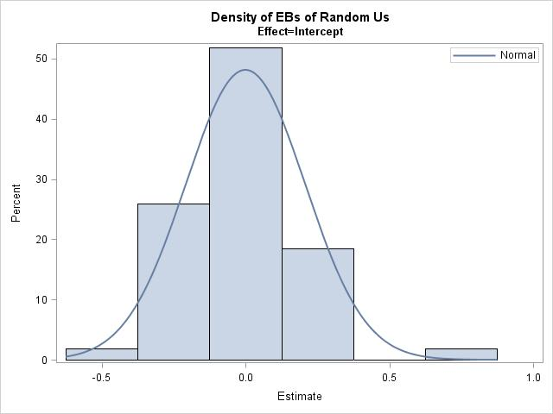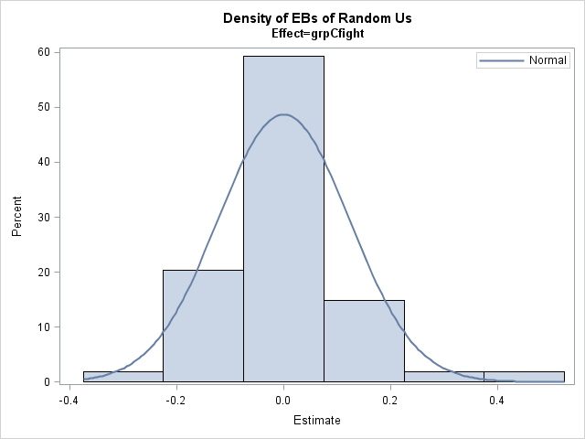

- Check for normality of bully residuals

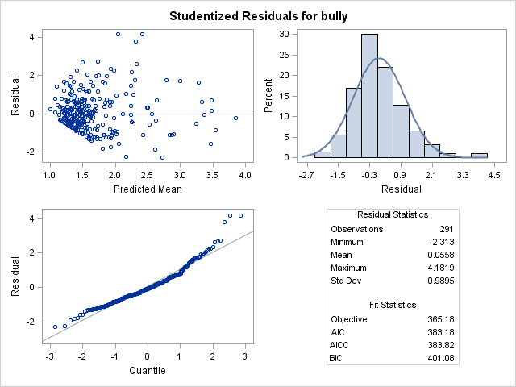
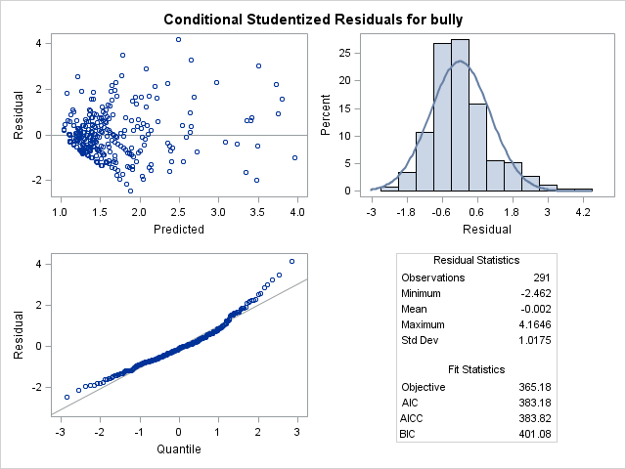

Histograms look skewed, and Q-Q plots tell a similar story. The plot of residuals by predicted mean shows that residuals of observations with relatively low bully scores are more clustered than those with high ones.

- Influence diagnostics:

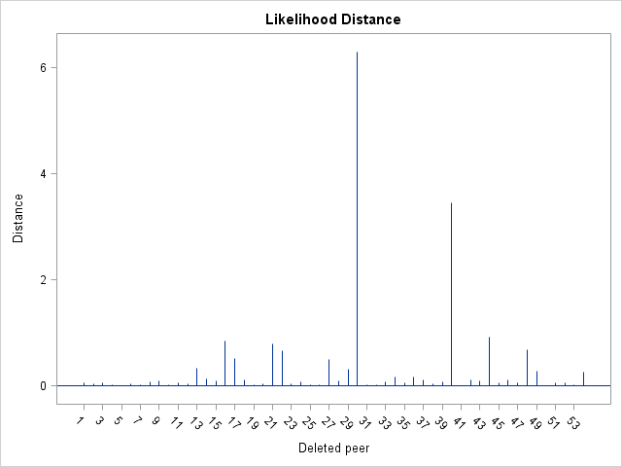

Based on the likelihood distance for groups, we can tell that there are two groups that ae extremely influential.

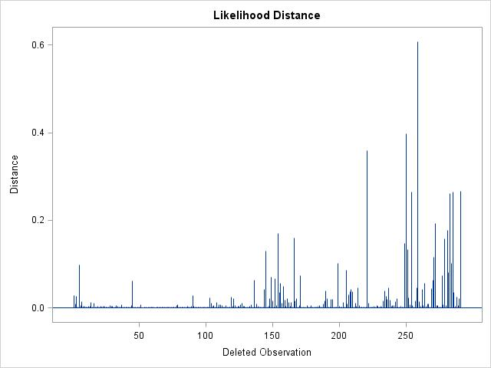
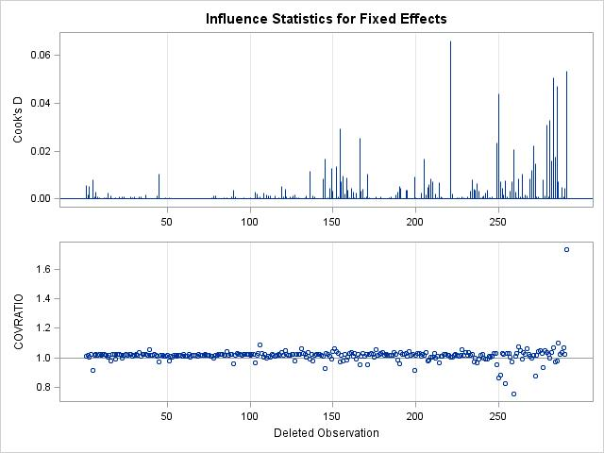

According to the influence diagnostics of individuals, we can tell that dropping some individuals will have a much bigger effect than dropping others, indicating that some participants are more influential to the model than others.

- Summary:

Q1:

- Being a bully does not differ based on child’s gender.
- Children with different tendency to fight tend to have different bully scores. To be more specific, those who have a high tendency to fight tend to have higher bully scores. The bully score increases by 0.47 units with every 1 unit increase of fight score compared with the mean level.
- Children with different levels of empathy tend to have different bully scores. To be more specific, those who have a high level of empathy to others tend to have lower bully scores. The bully score decreases by 0.08 units with every 1 unit increase of empathy score compared with the mean level.
Q2:
- There are differences between children’s levels of bullying due to the peer group to which they belong.
- Individuals belonging to groups with higher fight scores tend to have higher bully scores compared with individuals in lower fight score groups. With a 1 unit increase in the group mean level of tendency to fight, group members’ bully scores increase by 0.51.
- Individuals belonging to groups with higher empathy scores tend to have lower bully scores compared with individuals in lower empathy score groups. With a 1 unit increase in the group mean level of empathy, group members’ bully scores decrease by 0.11.

